ReSource
Data Design Document

Submitted to:

Asst. Prof. Ma. Rowena C. Solamo
Faculty Member
Department of Computer Science
College of Engineering
University of the Philippines, Diliman

Submitted by:
Jaira Mathena B. Angeles
Danilo M. Mendoza II
Beatrice Pauline R. Mercado

In partial fulfillment of Academic Requirements
for the course
CS 191 Software Engineering I
of the
1st Semester, AY 2019-2020
Unique Reference:
The documents are stored in the https://github.com/mathena828/ReSource.
ReSource - Data Design.pdf

Document Purpose:
The purpose of this document is to lay down the groundwork for the database design. It specifies the data elements that will constitute each of the classes. The organization of information on the web application will follow this general structure.

Target Audience:
The target audience of this document is the CS 191 and CS 192 Software Engineering classes of the academic year 2019 to 2020, as well as other individuals who may need to evaluate the functional requirements of this project. The members of Group No. 2, namely, Jaira Mathena B. Angeles, Danilo M. Mendoza II, and Beatrice Pauline R. Mercado will be creating and referencing this model. Professor Ma. Rowena C. Solamo will be evaluating the contents of this submission to ensure that it fulfills the criteria for this academic requirement.

Revision Control

History Revision:
Revision Date | Person Responsible | Version  Number | Contribution/Modification
10/11/2019 | Jaira Mathena Angeles | 1.0 | She filled out the preface, List of Data Source, and the Logical Database Design section.
10/24/2019 | Danilo M. Mendoza II | 2.0 | Created the Data Design models and filled in the Data Access Object(DAO) or DBClasses table
10/24/2019 | Beatrice Pauline R. Mercado | 3.0 | Filled in the table for Transfer Object or Persistent Classes.

Data Design:

BookListing
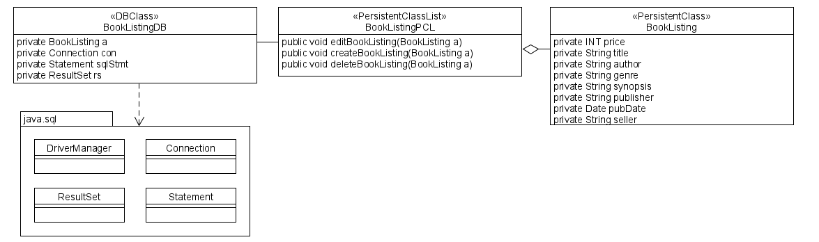

Account
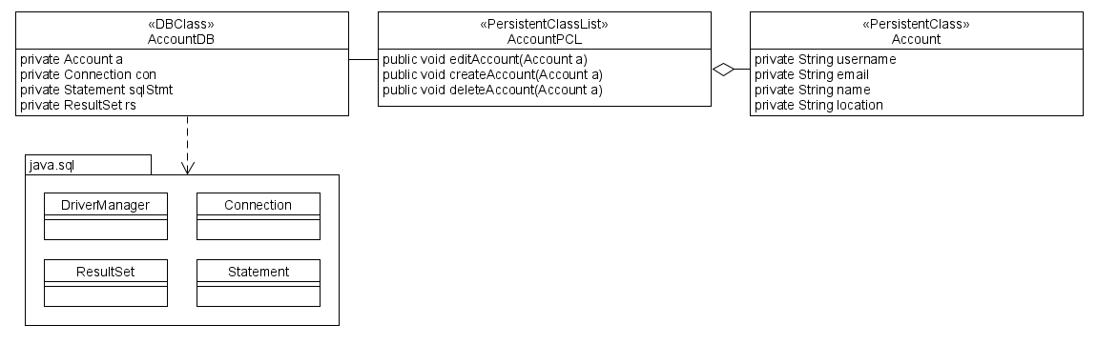

Data Access Object (DAO) or DBClasses:
Class Name | Description
BookListingDB | This database is responsible for storing and retrieving book listing records
AccountDB | This database is responsible for storing and retrieving account records

TransferObject or Persistent Classes:
Class Name | Description
BookListingPCL | This persistent class is responsible for maintaining the record for the book listing through create, edit, and delete functions.
BookListing | This persistent class is responsible for holding a single book listing record.
AccountPCL | This persistent class is responsible for maintaining the record for the accounts through create, edit, and delete functions.
Account | This persistent class is responsible for holding a single account record.

List of Data Source:

Database Name: Book Inventory Database
Description: This is the database that contains the inventory of books being sold by sellers on the ReSource web application. The following is the list of tables:

Tables | Descriptions
Book | It contains the records of all the books posted by sellers on the platform.
Account | It contains the account records.

Logical Database Design:

